Article ID: 3169
Article Name My fridge freezer does not refrigerate and does not freezes
Topic Location: Cooling/Fridge Freezer/Usage/Performance/Temperature
Meta-data:
Related Articles:
Related Questions:
PNC
DIY
Safety
Link
Email
X Book Engineer
Multimedia
Brand
Article Content:
The possible cause for the problem could be faulty power supply, electronic reset needed or the ambient temperature is too low.
Disconnect the appliance from power supply. Check the power supply socket by connecting another appliance and see if that works. If the power supply is ok, connect the appliance again. Disconnection and connection will also reset electronic parts on your appliance. Make sure the appliance is turned ON by the control panel or the thermostat. Information about how to turn on your appliance you will be able to find in your user instructions.
If the appliance placed in a garage, shed outbuilding or other cold environment:
See the climate classification indication on the rating plate. The proper operation can only be guaranteed for a SN-class appliance in a surrounding temperature of +10 to +32°C.
- Class N = 16-32°C
- Class SN = 10-32°C
- Class ST = 18-38°C
- Class SN/T = 10-38°C
Climate classification indication on rating plate:
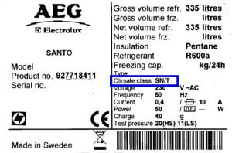
If none of the above advises solved the problem a service engineer can resolve it for you.
(Book engineer design)

